SEARCH_STRATEGY.md
Status: living document. Authoritative reference for the search stack; cite by section number in CC briefs (as we do with LEX_REBUILD_DESIGN.md). Update as pilots return data. Last revised: 2026-06-28 (v2 — adds the per-corpus stream model §3, the web-orientation layer, the synthesis structure §7, the original graph strategy §9, the type-taxonomy + callers §10, and feedback-driven evaluation §11).
Scrutinise lives or dies by search quality, so search decisions are made empirically, not by intuition. This document sets out what we are building, in what order, why, and how each piece fits with the others.

1. Governing principles
- Measure against the gold set, always. The offline evaluation harness (score-fts, gold queries, recall@20 + MRR) is the instrument. No search change ships on a hunch; it ships because it moved the number. The boost sweep (1.0 → 1.8 → 2.5) was this principle in action.
- Separate cheap-reversible decisions from expensive-sticky ones (§2). Tune the cheap ones freely. Pilot the sticky ones on a subset before committing at full scale.
- The corpus is ground truth. The LLM frames the search and writes the answer, but never asserts a fact the corpus did not return (§6a). This is how we stay grounded and avoid hallucinated law.
- Web is for orientation; the corpus is for the law you cite. Lex may use a web pass to understand the landscape and shape the corpus query, but any legal claim that enters the proposal must be backed by corpus text. Web sources are cited as background/current-context, visibly distinct from primary law. (This is principle 3 extended to the new source.)
- Index by function and outcome, not only by subject and citation. This is the design stance behind both the stream model (§3) and the graph strategy (§9): the connections that help a reformer are largely orthogonal to the ones that help a lawyer looking up the law.
- Every component is config-driven (model, chunk size, fusion weights, boosts, reranker on/off, which streams run). A variant is then a config change, scoreable on the gold set the same afternoon.

2. The core distinction — is vector "deterministic like FTS"? No.
This is the most important idea in the document, because it changes how we approach the build.
Keyword FTS (BM25) is cheap and reversible. The algorithm is fixed and well understood; the only levers are what we index and a handful of boosts/parameters, all of which we can change and re-score in minutes. There is no "wrong BM25 setting that silently poisons everything." Roughly: tune it, measure it, move on. (BM25 = the standard keyword-relevance score: term frequency × term rarity, length-normalised.)
Vector search is a quality continuum, dominated by two consequential, sticky choices:
- The embedding model. Models span a real quality range, and crucially embeddings from different models are incompatible — switching model means re-embedding all ~16.5M sections. High switching cost. Embeddings set the ceiling for retrieval quality; a bad embedding model cannot be fixed downstream by any reranker or prompt. (Embedding = a model that turns text into a vector so that similar meanings sit close together; "vector search" finds the nearest vectors to the query's vector.)
- Chunking. How we split a document into embeddable units (whole section vs paragraph vs sliding window) materially changes retrieval, and it is baked into the embeddings — changing it means re-chunking and re-embedding.
So vector is not "can't go wrong, go ahead." But it is not "must be perfect first time" either: it is one retriever in a hybrid system (BM25 + reranker cover its gaps), and it is de-riskable by piloting — embed a representative subset (~50–100k sections spanning the gold-set domains), score on the gold set, choose model + chunking, then commit at full scale.
The discipline is therefore: pilot → measure → commit. Same method that paid off on archetype A and on Finding B. We neither guess blind nor make a one-shot irreversible bet.

3. The per-corpus stream model
Legislation, debates, committees, case law, codes, investigations, evaluations and the web are different corpora with different characteristics, and we want different things from each. So we do not run one undifferentiated search and hope; we run specialised streams, each with its own query strategy and method weighting, and reassemble them — each stream's output able to inform another's query (§3.2).

3.1 Two kinds of stream — the load-bearing distinction
The sharpest cut is not by corpus but by what kind of thing you want back:
- Specific-retrieval streams want the exact item on the topic of the idea — this section, this ruling, this piece of evidence. You search by topic and return ranked hits.
- Principle-retrieval streams want transferable patterns, explicitly "general principles not specific items related to this search." Here you often must not search by the idea's topic at all — if the idea is housing eviction, you query the investigations corpus not for "eviction" but for the failure mode you suspect ("enforcement gap", "agency under-resourcing", "guidance ignored", "perverse incentive"). The lesson transfers because it came from a different domain. These streams return clustered, de-duplicated lessons (three representative patterns, not fifty near-identical ones) — not a ranked topical list.
The legislation-tier boost we shipped was a first crude step toward treating streams differently; this generalises it into the core of the design.
Stream | Kind | Purpose — what we want from it
Legislation | specific | the precise law to amend / add / revoke — what's there now
Debates (Hansard) | specific→principle | the issues behind the law; the contested views on causes & expected effects
Committees | specific→principle | evidence and hypotheses on causes & effects
Case law | specific + graph | how courts interpret the law; the real-world edge cases the legislation produced
Codes / guidance | principle | how legislation is implemented in practice — transferable even from unrelated law
Special investigations / inquiries | principle | how the civil service & public bodies actually behave; where it goes wrong; their incentives
Parliamentary evaluations of laws | principle | where laws succeed and fail — how government works, general principles not specifics
Web orientation | specific + principle | current-state landscape; academia/research; comparative ("what other countries do")

3.2 Reassembly is a dependency chain, not a merge
The streams are the skeleton of the agentic research loop (§4): one stream's output becomes another's query. There is a natural forward order:

Legislation ──(anchor Acts/sections)──▶ Case law ("cases interpreting these sections")
│ └──▶ Evaluations ("assessments of these laws")
▼
Debates ──(each contested cause)──▶ Committees / Web ("evidence on cause X")
│
▼
Mechanism of the chosen lever ──▶ Codes + Investigations + Evaluations
("how this kind of lever is implemented and where it fails")
│
▼
Web (comparative) ──▶ "what other countries did with this lever"
▼
SYNTHESIS (§7)
Each stream is a specialised retrieval tool with its own target and method; the synthesis layer assembles the streams into the briefing. This is exactly how the agent decomposes a broad complaint (§4) — so the same structure serves the simple briefing now and the ambitious policy-model later. We add streams in measurable stages (§5): a stream earns its place only when the gold set shows it improves the result, not because the architecture allows it.

4. Target architecture
The full pipeline. We build it incrementally (§5); this is the destination, not day one.
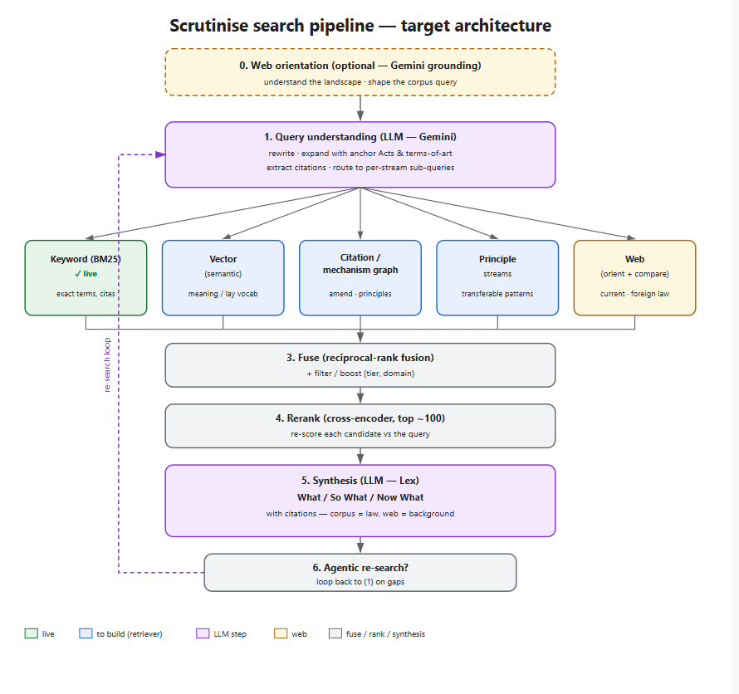
Reciprocal-rank fusion (RRF): merge several ranked lists by scoring each document 1/(k + its rank) in each list and summing. Needs no score calibration between retrievers — the default fuser.
Cross-encoder reranker: a model that reads the query and one candidate together and scores relevance. Far more accurate than retrieval scoring (which embeds query and document separately), but too slow over the whole corpus — so it runs only on the fused top ~100.
The LLM bookends the search; it does not do retrieval or core ranking. Front = orientation + query understanding (§6a); back = synthesis (§7); loop = agentic re-search. Chunk only at embedding time (vector layer; BM25 needs none). Rank twice: cheap-and-wide retrieval ranking per stream, then expensive-and-accurate reranking on the fused pool.

5. Layer roadmap — build order and rationale
Ordered by value per unit of effort. We start simple and add complexity in measurable stages, feeding what each stage teaches into the next.
# | Layer | Status | Fixes / adds | Why here
1 | Keyword FTS (BM25) + citation resolver + legislation boost | ✅ done | exact terms; citation lookup; term-of-art legislation | foundation; cheap to iterate
2 | Lex adapter (search wired into Lex) | ✅ done | real results in front of users | unblocks everything
3 | Query understanding / LLM expansion | confirmed next (background search first, then widen) | the lay-vocabulary gap (proven in Finding B); per-stream query routing begins here | cheapest fix for the biggest hole; one LLM call; days
3b | Web orientation pass | with/after 3 | landscape + current-state; shapes corpus query | cheap; avoids missing the obvious; grounding rule §1.4
4 | Vector / semantic (hybrid + RRF) | next major build | concept→meaning at the corpus side; lifts debates/principle streams most | durable vocabulary fix; first Hetzner job; pilot-measure-commit
5 | Reranker (cross-encoder) | after vector | final-ordering accuracy across all streams | highest-ROI multiplier once retrieval is decent
6 | Citation / amendment / metadata graph | after rerank | relationship queries; traversal by gov area & legislation type (§9 Tier 1) | explicit, factual; data-engineering
7 | Mechanism / principle graph (§9 Tier 2) | after 6 | principle-retrieval streams; "graph the principles" | the original layer; LLM-extraction build
8 | Institutional-outcome / argument / lineage graphs (§9 Tier 2) | later | causes, political risk, failure patterns, prior attempts | feeds the deep-policy agent; needs §9 base
9 | Archetype / domain projection | tuning | domain-mixture filtering & boosting | refinement on a stable base
10 | Behavioural co-interest graph (§9 Tier 3) | needs traffic | discovery / recommendation | gated on real usage
Note the ordering of 3 before 4. Finding B proved two failures wear one mask: term-of-art queries (MiFID) were retrieved-but-mis-ranked (the boost fixed it); lay-phrased queries were absent from the candidate set — BM25 cannot see them, because the statute's wording lacks the lay terms. Two complementary fixes: expand the query to contain the right words (layer 3, days) and match on meaning (layer 4, weeks). Ship the cheap one first; run it alongside building the durable one.

6. Layer detail (retrieval & LLM)

6a. Query understanding / LLM expansion — the "Gemini shape" idea
Confirmed, sequenced first (layer 3), scope = initial background search, then widen. Use a general LLM to get the shape of a legislative area and steer our own search; it directly targets the failure Finding B exposed.
The lay-vocabulary gap exists because the statute does not describe itself in lay terms: "data protection / privacy rights" never retrieves the Data Protection Act because the Act's operative text doesn't use those phrases. An LLM that knows "data protection → DPA 2018, UK GDPR, PECR" — or "Revoke MiFID II → COBS, SYSC, FSMA 2023, post-Brexit onshoring" — injects those names and terms-of-art into the corpus query so the anchor is retrieved. The query-side complement to vector's corpus-side fix, far cheaper to ship.
It is also, in effect, a dynamic, intelligent thesaurus — instead of a fixed synonym list it generates context-appropriate expansions on the fly, which is strictly more powerful, so we do not build a large static thesaurus. (A small curated legal term-of-art map could be a cheap targeted supplement if specific high-value mappings keep recurring.) Note: embeddings are weak on antonyms (opposites share context and sit close in vector space) — one more reason the hybrid keeps BM25.
Per-stream routing starts here. The same step expands one way for legislation (anchor Acts, terms-of-art) and another way for principle streams (failure-mode vocabulary, §3.1).
Guardrail — steer, never assert. The expansion is a query hint the corpus verifies, never a fact in the briefing. A hallucinated Act simply fails to surface. Start with the model's parametric knowledge of UK law; add web grounding (§3b) for currency; either way, steer don't assert.

6b. Vector / semantic search — and the embedding options
The durable fix for concept queries, built as a hybrid: vector fused (RRF) with BM25, keeping BM25 precision on exact terms and citations while gaining meaning-matching.
Model | ~Price /1M tokens | Profile
Gemini Embedding 001 | premium (Google) | leads English MTEB retrieval (~68); best API quality; lock-in
Voyage voyage-3-large / 3.1-large | ~$0.05–0.06 | domain-tuned: +4–6 pts on legal; strong legal pick, ~½ OpenAI-large cost
OpenAI text-embedding-3-small | ~$0.02 | budget default (~62 MTEB); most integrations; Matryoshka dims
Google text-embedding-005 | ~$0.006 | best price-performance; 20× cheaper
Qwen3-Embedding-8B (self-host) | GPU cost only | top open-weight; flexible dims, 32K ctx; cheaper >~100M tok/mo
BGE-M3 (self-host) | GPU cost only | dense and sparse vectors in one call — convenient for hybrid
Fine-tuned on our corpus | training cost | +10–30% on a specialised domain; the V3/V4 strategic asset
Cost anchor: a 1M-document pass ≈ $20 (OpenAI small) → $130 (OpenAI large). Our corpus chunks into tens of millions of units — a real budget line, another reason to pilot.
First pass: pilot 2–3 models — one budget general, one domain-tuned (voyage-3-large), optionally one open-weight — on the subset, score on the gold set, choose best cost/quality, scale on Hetzner. Lean domain-tuned unless cost forbids: the legal points matter and embeddings are a ceiling we can't raise later. Storage: a 1,024-dim float32 vector is 4KB; 10M ≈ 40GB; Matryoshka truncation trades quality for storage gracefully.

6c. Reranker (cross-encoder)
After retrieval is decent, typically the single highest-ROI component — re-scores the fused top ~100 against the query directly and fixes ordering across all streams at once. Cheap: a small open cross-encoder on our box, or a rerank API (Cohere / Voyage). Sequenced after vector because reranking a weak pool only re-sorts weak results; it multiplies a good pool.

7. Synthesis structure — What / So What / Now What
The briefing (and ultimately the policy model) is written in three moves, which map cleanly onto Rumelt and onto the streams:
Move | = Rumelt | Fed mainly by | Target insights
What | diagnosis (evidence) | legislation, case law, committees, web | what law exists; what was debated; what the courts/edge-cases show
So What | diagnosis (interpretation) | debates, investigations, evaluations | the causes (incl. non-obvious); significance; political risk
Now What | guiding policy + coherent actions | legislation, codes, web comparison | the lever; the precise amendable sections; implementation
The five target insights fall out of this: causes and political risk live in So What (debates, investigations, evaluations); policy, actions, implementation live in Now What (legislation, codes, comparative law). Original insight into causes — the non-obvious "deep search" — is the explicit aim of the principle streams (§3.1) and the argument/institutional graphs (§9).
By-product worth noting: the stream purposes (§3.1) are the precise specification of what a "good result" means per archetype. They should be folded into the gold set — e.g. a good investigations result is a transferable institutional pattern, not a topical match — which sharpens the measurement instrument itself.

8. (reserved — see §9 for the graph strategy)

9. Graph strategy — including the original layers
The great search innovations were graph re-framings: PageRank applied the academic citation graph to the web; Facebook built the social graph. The legal-citation graph (statute-cites- statute, case-cites-case) already exists in Westlaw/Lexis/CourtListener — so it is table stakes, not our edge. Our edge comes from a different question: existing legal search serves lawyers looking up what the law is; Scrutinise serves reformers trying to change it. That different user makes a different set of connections valuable — connections largely un-indexed because no existing product needed them.
The original move: index the corpus by function and outcome, not only by subject and citation. Two axes existing legal tech mostly ignores:
- Mechanism axis — what kind of lever is a provision, independent of its subject?
- Outcome axis — when that kind of lever was tried, what happened, and which body delivered it?
Both are now buildable for the first time because LLM extraction can read a provision or a report and emit typed nodes/edges at corpus scale — the thing that made these graphs impractical before. Edges live in Neon graph tables alongside the citation edges; construction is a corpus-processing pass like compilation.

Tier 1 — explicit / structural (factual, cheap, high precision)
- Citation / amendment graph — section-belongs-to-Act, amends, amended-by, commenced-by, case-interprets-section. Fixes the relationship-query archetype. Built directly from legislation.gov.uk structured data (changes feed, CLML). Non-hallucinated.
- Metadata graph — department / policy-area, instrument type, year, sponsoring committee. Derivable; enables traversal by area of government and by legislation type (your examples).

Tier 2 — semantic / inferred (LLM-extracted; the original, on-mission layers)
- Mechanism / principle graph — "graphing the principles" (the headline). Tag every provision with its mechanism type — duty-to-report, licensing regime, statutory time limit, sunset clause, strict-liability offence, regulator-with-powers-X, funding mechanism — and connect provisions sharing a mechanism across subjects. Lets you ask "show every way Parliament has implemented a duty-to-report, across all domains, and how each fared." Novel because existing legal search is subject-organised; mechanism is an orthogonal axis no one indexes. This is the structural backbone of the principle-retrieval streams (§3.1).
- Intent / problem→lever graph. Nodes include problems, claimed causes, levers, outcomes — not just documents. Edges: "this Act intended to address this problem", "this problem has these claimed causes", "this lever was the chosen mechanism". Teleological — captures why law exists. Extracted from explanatory notes, second-reading debates, impact assessments. Given a new problem: "what levers have been tried for problems like this".
- Institutional-outcome / failure-pattern graph. Connect provision/policy → delivery body → failure-mode (enforcement gap, under-resourcing, perverse incentive, guidance ignored, gaming) → outcome. Fed by investigations, evaluations, NAO — and the crowd-sourced campaign corpus (separate plan) plugs in here. Predictive: a new proposal using mechanism M delivered by body-type B → "when M was delivered by bodies like B, here is what failed." The real-world evidence base, as a graph.
- Argument / contested-cause graph (debate graph). From Hansard, extract claims-about-causes/ effects and positions (who argued what, what evidence). Edges: supports / contradicts / cites. Surfaces the space of contested causal hypotheses and who holds them → directly the So What diagnosis and the political-risk insight.
- Lineage-of-attempts graph (temporal). Thread bills (incl. failed/withdrawn), Acts, amendments, repeals along a problem over time. "Everything tried here and what happened." Novel because failed bills are usually dropped from legal databases but are gold for reformers.

Tier 3 — behavioural (needs usage data; later)
- Co-interest graph — "people interested in defence also engage with welfare cuts." Discovered from engagement once there is traffic; recommender pattern. Note (from §3-discussion): clustering and embeddings discover such groupings without us enumerating them — we don't hand-design 50 relationship types; the high-value ones emerge.

Discipline
These Tier 2/3 edges are inferred, so: tag every edge with provenance/confidence (the one good idea borrowed from graphify's EXTRACTED/INFERRED/AMBIGUOUS), and gate each layer on the gold set — build the explicit Tier 1 first, then the mechanism graph (most original, most on-mission), measure, expand. A graph over bad retrieval is bad, so these come after vector + rerank (§5).

10. The seam, the type taxonomy, and the callers

10.1 The seam (the interface retrieval builds to)
The platform consumes a fixed shape: query → SearchResult[] with { id, type, title, citation, snippet, score, url, date }. Lex never calls the corpus directly; the platform calls at deterministic, platform-owned trigger points (§10.3). The FTS service needs no change for stage 3 — expansion happens platform-side, before runFtsSearch.

10.2 Type taxonomy — resolve the too-narrow enum (open action)
The 5-type enum (PRIMARY_LEGISLATION | STATUTORY_INSTRUMENT | DEBATE | COMMITTEE | CASE_LAW) is too narrow for the real corpus (~54 raw source types). Resolution = a three-level taxonomy, all mappings owned in one place (corpus-type-map):
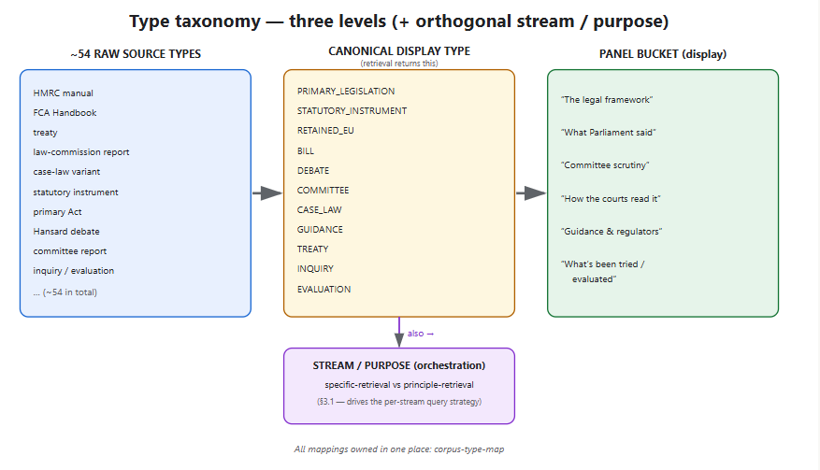
Retrieval returns the canonical display type; the panel groups into buckets with no per-source special-casing; the stream/purpose grouping is orthogonal, used by orchestration. Action: CC to confirm the canonical list against the real 54 raw types and own the mapping in corpus-type-map.

10.3 The callers (where/when search is called in the Lex flow)
- Page 1 (Orientation), on keywords-accept → background briefing search. This one gets stage-3 expansion first.
- Page 2 (Diagnosis) → corpus-seeding of candidate causes (past debates/committee reports where the problem was examined — "this has been looked at before"). Live FTS via the seam.
- Pages 3–4 (forward) → guiding-policy alternatives (later comparative/foreign law); coherent-actions precise amendable sections (section-level legislation + citation).
Query types the design anticipates: precedent (debates/committee), precise amendable sections (legislation, section-level + citation), case-law interpretation, comparative/foreign law.

10.4 Latency headroom
The background briefing is not latency-critical — framed as "I've prepared a briefing" — so a few seconds for stage-3 expansion and/or a web pass is acceptable (~1–3s tolerance confirmed).

11. Evaluation, A/B, and feedback signals
Now: offline gold-set scoring is the A/B mechanism. With one real user, there is no live traffic to split for significance; the gold set fills that role (run variant configs, compare recall@20 / MRR). Each variant is a config change (§1.6) scored the same day.
Feedback feature as an early signal source. When a user critiques a briefing, Lex strips personal content, summarises the technical points and (with consent) stores it (DB record + email to cl@scrutinise.org). Much of this critique is about search quality ("found a few random things", "missed the obvious") — so it is an early source of observed queries + quality signals to mine for the gold set, ahead of real traffic. Wire this into the gold-set growth process.
Concrete gold-set candidate: the live "Revoke MiFID II" test — external Google comparison gives validated should-find targets (FCA Handbook COBS/SYSC, FSMA 2023, post-Brexit onshoring); a good lay-concept archetype query.
Later: real-user A/B, splitting live traffic, once usage supports significance.
The foundational investment is the gold set itself — the instrument behind every decision here. Growing and validating it (the outstanding expected-sources pass, plus the §7 per-stream "good result" definitions, plus mined feedback) is the highest-leverage non-build task we have.

12. Immediate next steps
- Build layer 3 — LLM query-expansion (background search first). Cheapest fix for the proven lay-vocabulary gap; begins per-stream routing; ships in days. Add the web-orientation pass (§3b) under the grounding rule.
- Validate + grow the gold set — the expected-sources pass, the "Revoke MiFID II" candidate, the §7 per-stream good-result definitions, and mined feedback (§11). Foundational.
- Run the vector pilot (layer 4): 2–3 embedding models → embed the ~50–100k subset → score on the gold set → commit the winner → scale on Hetzner.
- Reconcile the type taxonomy (§10.2): CC confirms the canonical list against the 54 raw types and owns the mapping.
- Then reranker (5), then the graph layers — explicit first (6), then the mechanism / principle graph (7), then the institutional-outcome / argument / lineage graphs (8).
Each step is gated on the gold-set number moving, or on enabling a query archetype we cannot otherwise serve. The whole strategy in one sentence: run specialised streams, index by function and outcome as well as subject, let the LLM frame and finish, and never ship a change the gold set didn't reward.

